Developing your understanding 16.5

1 Identify where most of ancient China’s population lived.

2 What Confucian values contributed to the importance of the family in ancient China?

3 Compare the different approaches to the idea of law presented by the philosophies of Legalism and Confucianism.

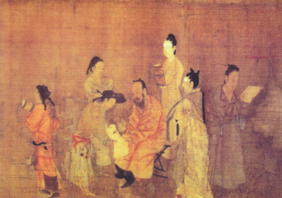
Source 16.7 Painting of a northern Qi scholar official, assisted in his
writing by servants

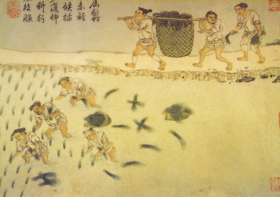
Source 16.8 Painting of peasants at work in a rice field

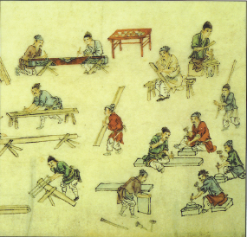
Source 16.9 Painting from Eastern Han period
showing various artisans working with wood,
stone and lacquer paint

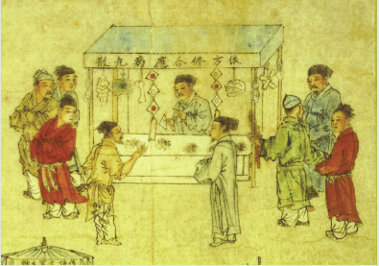
Source 16.10 Painting of a merchant selling his wares

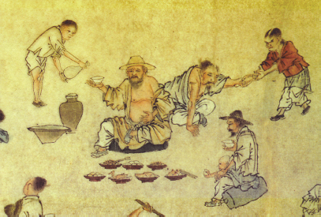
Source 16.11 Painting showing a slave pouring a drink, while another
slave assists someone to stand up

4 Examine Sources 6.7–11 closely:
A What different types of work can you recognise?

B For each example of work you identify, suggest the social class to which that person might belong.

